Not for reproduction CISPR/A/WG1_(Jong-Hyuk Lim, Bo-Weon Lee ) 16-01

Original: English October 2016

**INTERNATIONAL ELECTROTECHNICAL COMMISSION**

**INTERNATIONAL SPECIAL COMMITTEE ON RADIO INTERFERENCE (CISPR)**

Subcommittee A: Radio Interference Measurements and Statistical Methods

Working Group 1: EMC Measurement Instrumentation

Subject: A study of standard antenna using two homogeneous horn antennas in the frequency range of 1 ㎓ - 18 ㎓

References :

[1] K.T. Selvan, “A modified three-antenna gain measurement method to simplify uncertainty stimation,” Progress In Electromagnetics Research, PIER 57, page 197-208, 2006.

[2] ANSI C63.5 , “American National Standard for Electromagnetic Compatibility-Radiated Emission easurement in Electromagnetic interference(EMI) Control-Calibration of Antennas (9 kHz to 40 GHz)”, pp. 10, April 2006.

[3] IEEE Standard Test Procedures for Antennas, ANSI/IEEE Std 149-1979, Dec. 1979.

[4] J. K. Park, W. N. Kim, B. G. Kang, , and H. K. Yeon, “A Novel Reference Antenna Method for EMI Antenna Calibration,” URSIGASS Symp., pp. 1-4, Aug. 2014

Authors : Jong-Hyuk Lim, Bo-Weon Lee

1. **Introduction**

Antenna calibration is to measure the antenna factor (AF). The antenna factor measurement methods, which are three antenna method (TAM) [1], standard site method (SSM) [2], standard antenna method (SAM) [3], [4] are mainly used in the world. As shown in ref. [1] – [3], they should be measured twice or three times with three antennas in order to calibrate the precise antenna factors. However, R-SAM introduced in [4] is able to calculate the antenna factor with a single measurement configuration. R-SAM needs an information for electric fields at receiving location. Standard antenna knowing antenna factor can determined such an electric fields. If there are two homogeneous antennas, the same antenna factors can be easily calculated by measuring a site insertion loss (SIL) between two antennas and this standard antenna can be used as R-SAM.

In this report, we propose a new concept of standard antenna using two homogeneous pyramidal horn antennas in the frequency range of 1 GHz – 18 GHz. Homogeneous means that they have the same characteristics within 0.2 dB difference. And then we determine the same antenna factors of two homogeneous horn antennas by measuring a SIL between two antennas only once. In order to verify the validity of R-SAM, we calibrate an arbitrary wideband horn antenna(C) in two ways, the R-SAM and the TAM and compare the two results. Two antenna factors obtained by two measurement methods are up to 0.2 dB difference. Therefore, validity of the R-SAM is demonstrated.

1. **A NEW CONCEPT OF STANDARD ANTENNA**

The antenna factor is useful parameters in order to determine the unique performance of an antenna. It is defined as the ratio of the field strength (*E*) to the voltage (*V*) induced at the receiving antenna as follows.

 (1)

When the transmitting (*Tx*) and the receiving (*Rx*) antenna factors are *AF*TX and *AF*RX, respectively and the SIL is a site insertion loss. The antenna factor is as follows.

 (2)

Where, *f*MHz is the frequency in MHz unit, *d* is the distance in m unit between two antennas.

If the *Tx* antenna and the *Rx* antenna are the homogeneous in the equation (2), the same antenna factors can be easily calculated by measuring a SIL between two antennas. The same antenna factors, *AFTX* = *AFRX*, are as follows.

 (3)

At this time, the *Tx* antenna and the *Rx* antenna are defined to be equal to within 0.2 dB difference. Therefore, these homogenous horn antennas can be defined as a new type of the standard antenna.

1. **ANTENNA DESIGN AND HOMOGENIETY TEST**

In order to obtain simple standard antenna factor proposed needs two homogeneous antennas. Here the homogeneous antennas are defined as it should have an equal physical property. As shown in Fig. 1, the proposed pyramidal horn antenna consists of rectangular waveguide, horn aperture, and a feeding connector. The proposed antenna configuration is simulated using high frequency structure simulator (HFSS) which is a commercial electromagnetic field solver. And then the proposed antenna is fabricated using aluminum with thickness of 4 mm.

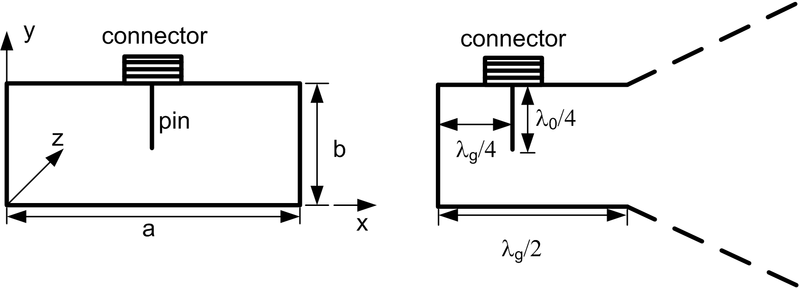

Fig. 1. Structure of rectangular waveguide and horn aperture.

To obtain the same property two antennas are fabricated by using a numerical computer (NC) process with tolerance of 0.01 mm. In order to confirm the homogeneity of fabricated two horn antennas (A and B), we measure the site insertion losses (SIL) of the two antennas in open area test site (OATS) of the national Radio Research Agency. We also use an arbitrary wideband horn(C), which is SCHWARZBECK BBHA9120 D model, to transmitting antenna and measure the amount of attenuation between the antennas by using a substitute method as shown in Fig. 2. Homogeneity is demonstrated from the above verification in the frequency range of 1 GHz - l8 GHz. All measured results are satisfied within 0.2 dB.

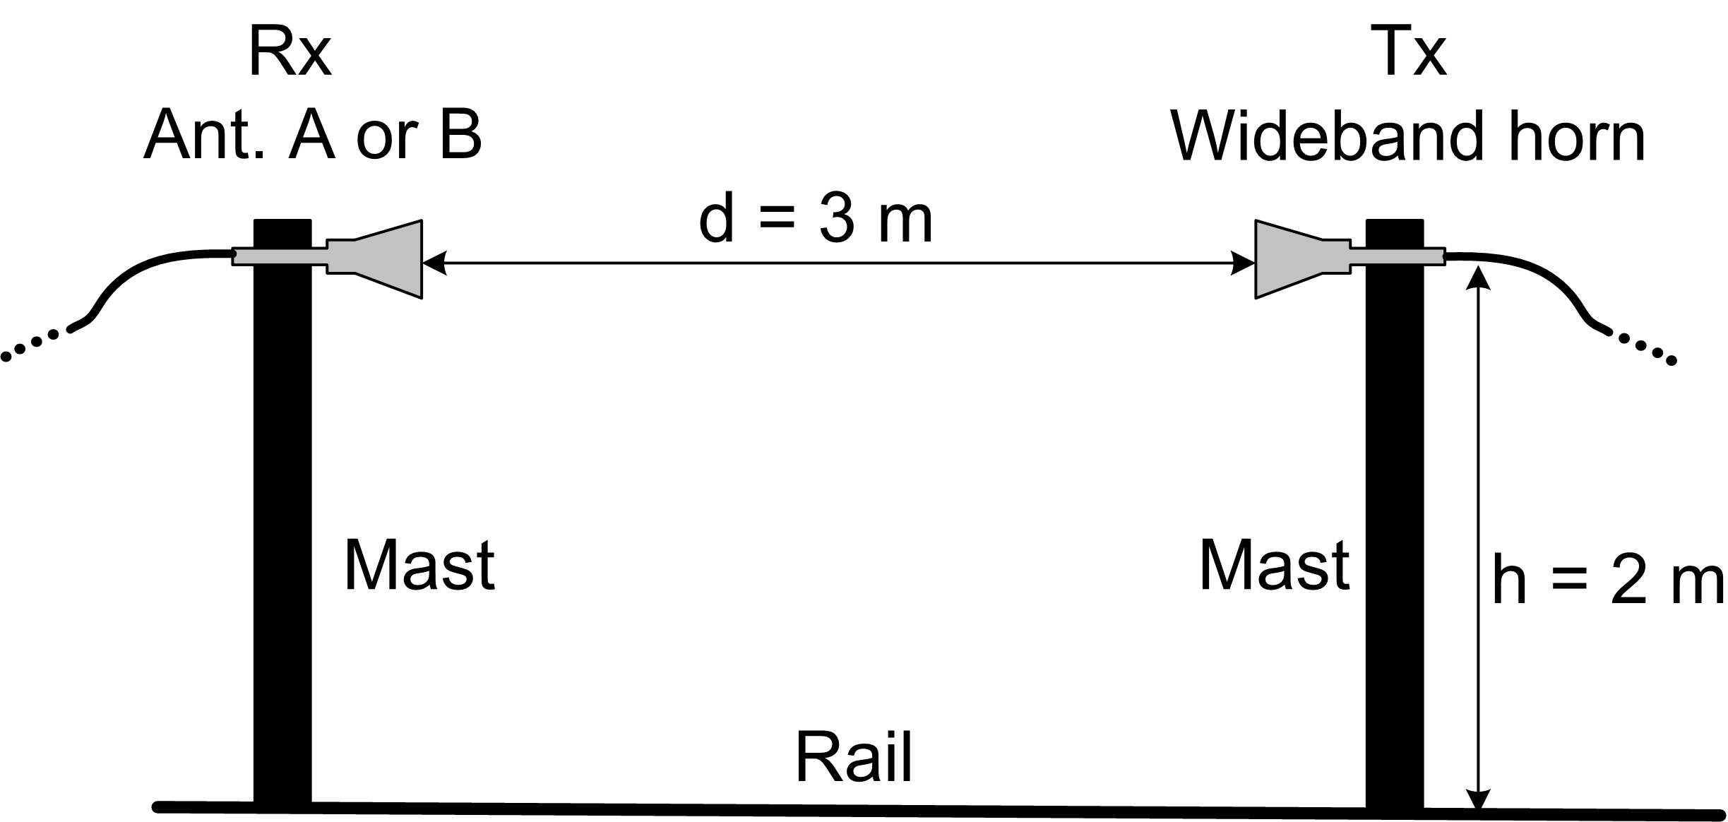

Fig. 2. Measurement environment for an equivalence test.

1. **EXPERIMENTAL VERIFICATION**

The same Antenna factors of the fabricated horn antennas can be easily calibrated by the formula (3). It is possible that only one measurement of the amount of SIL between the antennas. And then the heights of antenna from the ground and the distances between two antennas are set to 3 m and 2 m, respectively, as shown in Fig. 2.

In order to verify the validity of R-SAM, we calibrate an arbitrary wideband horn antenna(C) in two ways, the R-SAM and the TAM. Antenna factors of the wideband antenna(C) obtained by two methods are compared each other and the maximum deviation of two methods shows less than 0.2 dB, as shown in Fig. 3 – Fig. 9. As results, the verification of the R-SAM using the standard antenna is demonstrate.



Fig. 3. Measured Results of R-SAM and TAM from 1.12 GHz to 1.8 GHz : (a) antenna factors, (b) deviation



Fig. 4. Measured Results of R-SAM and TAM from 1.8 GHz to 2.6 GHz : (a) antenna factors, (b) deviation



Fig. 5. Measured Results of R-SAM and TAM from 2.6 GHz to 3.95 GHz : (a) antenna factors, (b) deviation



Fig. 6. Measured Results of R-SAM and TAM from 3.95 GHz to 5.85 GHz : (a) antenna factors, (b) deviation



Fig. 7. Measured Results of R-SAM and TAM from 5.85 GHz to 8.2 GHz : (a) antenna factors, (b) deviation



Fig. 8. Measured Results of R-SAM and TAM from 8.2 GHz to 12.4 GHz : (a) antenna factors, (b) deviation



Fig. 9. Measured Results of R-SAM and TAM from 12.4 GHz to 18 GHz : (a) antenna factors, (b) deviation

1. **Conclusions**

A new concept of the standard antenna using two homogeneous antenna is proposed. We also present two homogeneous pyramidal horn antennas in the frequency range of 1 GHz – 18 GHz. This homogeneity within 0.2 dB is verified through experiments. We show that the same antenna factors can be easily calculated by measuring a site insertion loss (SIL) between two antennas. In order to verify the validity of R-SAM using the standard antenna, we calibrate an arbitrary wideband horn antenna(C) in two ways, the R-SAM and the TAM and compare the two antenna factors. The difference of two measurement results show less than 0.2 dB. Therefore, this method can be used to calibrate the antenna.

As the final outcome, we strongly suggest as follows

* If there are two homogeneous antennas, the same STAs can be easily calculated by measuring a site insertion loss (SIL) between two antennas and this standard antenna can be used as R-SAM.
* The existing calibration methods of EMI antenna have to use three antennas. Even the SAM requires a set of STAs having the accurately determined AF. However, R-SAM requires only one STA.
* We suggest alternative SAM using a standard horn antenna (STHA) in the frequency ranges of 1 GHz – 18 GHz.